Domaine de la Chartreuse – inventaire de la friche Matexi – 28 octobre 2020
J.-Y. Baugnée

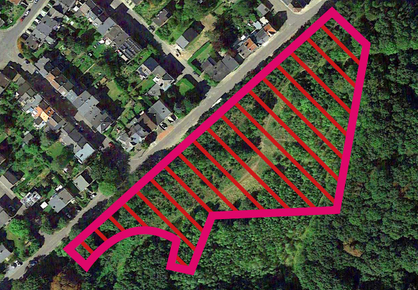

Plantes supérieures (n = 93)
Acer platanoides
Acer pseudoplatanus
Achillea millefolium
Alliaria petiolata
Arenaria serpyllifolia
Arrhenatherum elatius
Artemisia vulgaris
Betula pendula
Betula pubescens
Buddleja davidii
Calamagrostis epigejos
Carex flacca
Carex hirta
Carex spicata
Centaurea jacea s.l.
Cerastium fontanum
Chelidonium majus
Cirsium arvense
Clematis vitalba
Cornus sanguinea
Corylus avellana
Cotoneaster hjelmqvistii
Crataegus monogyna
Dactylis glomerata
Daucus carota
Dryopteris filix-mas
Epilobium hirsutum
Epilobium sp.
Epipactis helleborine
Equisetum arvense
Eupatorium cannabinum
Fagus sylvatica
Festuca filiformis
Fraxinus excelsior
Galium mollugo
Geranium robertianum
Geum urbanum
Hedera helix
Heracleum sphondylium
Hieracium lachenalii
Hieracium sabaudum
Hypericum perforatum
Ilex aquifolium
Juncus effusus
Lathyrus pratensis
Lemna minuta
Leontodon autumnalis
Linaria vulgaris
Lolium perenne
Lotus corniculatus
Lythrum salicaria
Odontites vernus subsp. serotinus
Persicaria sp.
Phragmites australis
Picea abies
Picris hieracioides
Pinus sylvestris
Plantago lanceolata
Poa annua
Poa compressa
Poa nemoralis
Polygonum aviculare
Populus alba
Populus nigra var. italica
Populus tremula
Prunus avium
Prunus laurocerasus
Quercus robur
Ranunculus acris
Ranunculus repens
Rosa canina s.s.
Rubus caesius
Rubus fruticosus
Rubus sp.
Rumex acetosa
Rumex crispus
Rumex obtusifolius
Salix alba
Salix caprea
Salix viminalis
Salix x multinervis
Sambucus nigra
Senecio jacobaea
Solidago gigantea
Tanacetum vulgare
Taraxacum sp.
Taxus baccata
Tilia platyphyllos
Torilis japonica
Trifolium pratense
Trifolium repens
Tussilago farfara
Urtica dioica
Vicia sepium

Champignons (n = 10)
Arrhenia retiruga
Hygrocybe mucronella
Hypholoma fasciculare
Lactarius pubescens
Mallocybe fuscomarginata
Rhytisma acerinum
Rhytisma salicinum
Russula exalbicans
Stropharia caerulea
Xylaria hypoxylon

Oiseaux (n = 15)
Buteo buteo
Columba palumbus
Erithacus rubecula
Fringilla coelebs
Garrulus glandarius
Motacilla cinerea
Parus caeruleus
Parus major
Phylloscopus collybita
Pica pica
Picus viridis
Troglodytes troglodytes
Turdus iliacus
Turdus merula
Turdus pilaris

Reptiles (n = 1)
Anguis fragilis

Amphibiens (n = 2)
Ichthyosaura alpestris
Rana temporaria

Arachnides (n = 4)
Aceria populi
Eriophyes tiliae
Gibbaranea gibbosa
Phytoptus avellanae

Coléoptères (n = 7)
Aphthona euphorbiae
Chilocorus renipustulatus
Coccinella septempunctata
Exochomus quadripustulatus
Harmonia axyridis
Orchestes quercus
Rhamphus oxyacanthae

Diptères (n = 15)
Campiglossa misella
Dasineura rosae
Dasineura trifolii
Eristalis tenax
Iteomyia capreae
Lasioptera rubi
Lipara lucens
Macrodiplosis pustularis
Macrodiplosis roboris
Massalongia ruber
Rabdophaga rosaria
Rhopalomyia tanaceticola
Sargus bipunctatus
Sphaerophoria scripta
Urophora cardui

Hémiptères (n = 16)
Aphrophora alni
Cryptosiphum artemisiae
Empoasca vitis
Errastunus ocellaris
Issus coleoptratus
Kleidocerys resedae
Lamprotettix nitidulus
Linnavuoriana sexmaculata
Lygus rugulipennis
Palomena prasina
Rhaphigaster nebulosa
Stenocranus minutus
Stictopleurus punctatonervosus
Tingis crispata
Trioza remota
Zyginidia scutellaris

Hyménoptères (n = 13)
Andricus solitarius
Aulacidea hieracii
Auplopus carbonarius
Cynips divisa
Formica fusca
Lasius niger
Neuroterus albipes
Neuroterus anthracinus
Neuroterus quercusbaccarum
Pediaspis aceris
Pontania pedunculi
Profenusa pygmaea
Vespula vulgaris

Lépidoptères (n = 45)
Bucculatrix noltei
Bucculatrx ulmella
Caloptilia cuculipennella
Caloptilia sp.
Caloptilia stigmatella
Coptotriche angusticollella
Coptotriche marginea
Dahlica triquetrella
Ectoedemia albifasciella
Ectoedemia hannoverella
Ectoedemia occultella
Ectoedemia subbimaculella
Gracillaria syringella
Lyonetia clerkella
Parornix anglicella
Parornix devoniella
Phyllocnistis extrematrix
Phyllocnistis labyrinthella
Phyllocnistis saligna
Phyllocnistis xenia
Phyllonorycter comparella
Phyllonorycter geniculella
Phyllonorycter joannisi
Phyllonorycter populifoliella
Phyllonorycter salicicolella
Phyllonorycter sp.
Phyllonorycter ulmifoliella
Proutia betulina
Stigmella aceris
Stigmella anomalella
Stigmella aurella
Stigmella basiguttella
Stigmella confusella
Stigmella hybnerella
Stigmella microtheriella
Stigmella oxyacanthella
Stigmella perpygmaeella
Stigmella ruficapitella
Stigmella sakhalinella
Stigmella salicis
Stigmella speciosa
Stigmella trimaculella
Tischeria dodonaea
Tischeria ekebladella
Vanessa atalanta

Odonates (n = 2)
Aeshna cyanea
Sympecma fusca

Orthoptères (n = 3)
Meconema meridionale
Pholidoptera griseoaptera
Tetrix undulata

Crustacés Isopodes (n = 3)
Oniscus asellus
Philoscia muscorum
Porcellio scaber

Mollusques gastéropodes (n = 6)
Cornu aspersum
Helix pomatia
Hygromia cinctella
Trochulus hispidus
Vallonia costata
Vallonia excentrica

